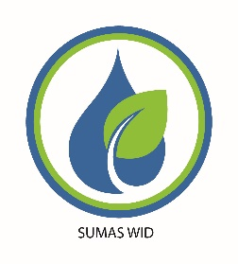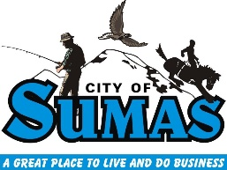

**Sumas River Flood Management**

The City of Sumas, the Sumas WID (Watershed Improvement District), and the Johnson Creek and Saar Creek Drainage Districts are cooperating on a joint application to FEMA to address the flood damage to the engineered drainage system caused by the November flood event. This is an historic opportunity to make use of the federal partnership to restore the Sumas area drainage system in a manner that provides drainage, fish habitat, and flood management beneficial for the entire Sumas community.

The FEMA application has been in progress since early 2022. FEMA has been very supportive of our work and they provide 90% of all necessary funding. The State provides an additional 5% and is considering covering the remaining 5% which, at present, is paid by the applicants.

We intend to remove debris and sediment in the Sumas River, its tributaries (Johnson, Bone, and Kneuman Road ditch) and Saar Creek. We hope to do some initial work this fall but the entire project may be accomplished over 3 – 5 years.



The next steps will be a survey of the areas planned for initial work, obtaining the State and County permits needed to do the work, developing an acceptable debris removal plan in cooperation with the drainage districts and all affected property owners, and finally engaging construction contractors to do the work.

Drainage Districts have legal access to these streams for construction and maintenance. But access will involve multiple property owners and we will always respect your concerns and property rights. We expect surveying to occur in late July, early August and are hopeful some debris removal may be permitted in time for the fall window when fish are least affected.

We recognize that this work does not address the Nooksack River flooding that caused the most damage last fall. That is being addressed by County, State, and Federal agencies. We will cooperate with them whenever we can but we don’t intend to wait for them to begin addressing what we need to manage.

You can learn more about the project from the project partners listed below. We hope you will agree with us that we should not ignore this opportunity to make our water management system better for all.

City of Sumas – Public Works Director – Sunny Aulakh – [saulakh@cityofsumas.com](mailto:saulakh@cityofsumas.com)

Sumas WID – [www.sumaswid.com](http://www.sumaswid.com) - [info@sumaswid.com](mailto:info@sumaswid.com)

Johnson Creek DID – Terry Lenssen, boardmember

Saar Creek DID – Mike Horat, boardmember